

FOR IMMEDIATE RELEASE
September 15, 2026
Media Contact: Motley Crew Media for Broadway at the Hobby Center
Nicole Shiro | 512.740.6665 | nicole.shiro@motleycrewmedia.com
Amy S. Layton | 512.695.0799 | amy.layton@motleycrewmedia.com
IMAGES AND INTERVIEWS AVAILABLE UPON REQUEST
TICKETS ON SALE FRIDAY, SEPTEMBER 18 AT 10AM
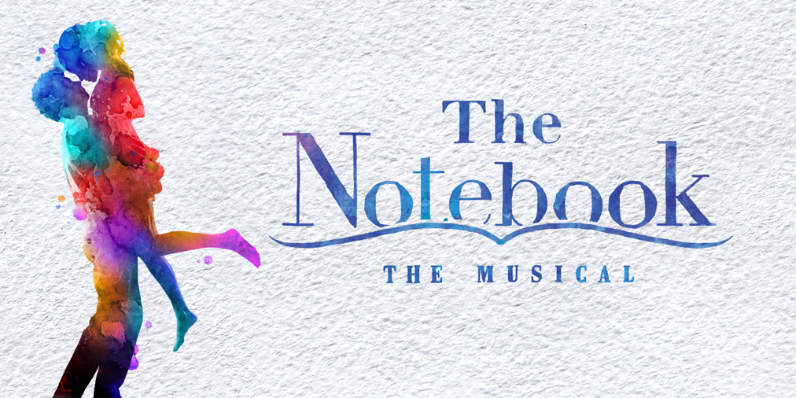
ACCLAIMED BROADWAY MUSICAL
BASED ON THE BESTSELLING NOVEL THAT INSPIRED THE ICONIC FILM
THE NOTEBOOK HOUSTON PREMIERE AT
THE HOBBY CENTER JANUARY 5 – 10, 2027
FEATURING AN AWARD-WINNING CREATIVE TEAM
Music & Lyrics by INGRID MICHAELSON
Book by BEKAH BRUNSTETTER
Choreography by KATIE SPELMAN
Directed by MICHAEL GREIF and SCHELE WILLIAMS
“A romantic musical for the ages.” – Chicago Sun-Times
WHO: Memorial Hermann Broadway at the Hobby Center
WHAT: THE NOTEBOOK
WHEN: January 5 – 10, 2027
Tues – Fri at 7:30 pm | Sat at 2 & 7:30 pm | Sun at 1:30 & 7:00 pm
WHERE: The Hobby Center | 800 Bagby Street | Houston, TX 77002
TICKETS: Start at $55. Available online at TheHobbyCenter.org or BroadwayAtTheHobbyCenter.com, and in person at the Hobby Center Box Office (800 Bagby Street, Houston, TX 77002). Discounts available for groups of 10 or more. Call (713) 315-2594 or email groups@thehobbycenter.org.

(HOUSTON, TX) – Producers Kevin McCollum and Kurt Deutsch, along with Memorial Hermann Broadway at the Hobby Center announce single tickets for THE NOTEBOOK, a new musical based on the best-selling novel that inspired the iconic film, will go on sale to the general public on Friday, September 18 at 10 am. THE NOTEBOOK will make its Houston premiere for a limited one-week engagement at the Hobby Center for the Performing Arts, January 5 – 10, 2027 as part of the Memorial Hermann Broadway at the Hobby Center 2026-2027 Season, where Houstonians are about to fall in love all over again with this beloved story.
“THE NOTEBOOK is ultimately a celebration of life, love, and the power of memory,” said producers Kevin McCollum and Kurt Deutsch. “Audiences first fell in love with this timeless story as a novel, then as an iconic film, and now they can experience it anew as a moving musical event. With multi-platinum artist Ingrid Michaelson’s unforgettable score and Tony Award nominated Bekah Brunstetter’s beautifully crafted book, THE NOTEBOOK comes to life on stage in a way that will resonate deeply with audiences across North America.”
Allie and Noah, two people from different worlds, share a lifetime of love despite the forces that threaten to pull them apart. “Full of butterfly-inducing highs and beautiful songs” (Entertainment Weekly), THE NOTEBOOK a deeply moving portrait of the enduring power of love.
Based on the book that has sold millions of copies worldwide and a film that is one of the highest-grossing romantic dramas of all-time, the musical adaptation of THE NOTEBOOK played Broadway at the Schoenfeld Theatre from March 2024 to December 2024 following a critically acclaimed world premiere engagement at Chicago Shakespeare Theater in the fall of 2022.
“Absolutely gorgeous. Not to be missed.” – Chicago Tribune
THE NOTEBOOK features music and lyrics by multi-platinum singer-songwriter Ingrid Michaelson and a book by playwright Bekah Brunstetter (writer and producer on NBC's “This Is Us,” The Cake). The production is directed by Michael Greif (Dear Evan Hansen, Next to Normal, RENT) and Schele Williams (Aida, The Wiz), with choreography by Katie Spelman (Associate Choreographer on Moulin Rouge! The Musical).
“Romantic, life-affirming and ingeniously adapted.” – USA Today
The creative team for the tour includes scenic design by David Zinn and Brett J. Banakis, costume design by Paloma Young, lighting design by Ben Stanton, sound design by Nevin Steinberg, hair and wig design by Mia Neal, and projection design by Lucy Mackinnon. The production’s music supervisor is Carmel Dean, who also collaborated on arrangements with Ingrid Michaelson and on orchestrations with John Clancy, and the music director is Tina Faye. Casting by The Telsey Office, Patrick Goodwin, CSA.
The production was recently recognized with three 2024 Tony Award nominations (Best Book of a Musical, Best Performance by an Actress in a Leading Role in a Musical, Best Performance by an Actor in a Leading Role in a Musical), Drama League Award nominations for Outstanding Production of a Musical, two Distinguished Performance Awards and the Founders Award for Excellence in Directing, Drama Desk Award nominations for Outstanding Featured Performance in a Musical, and an Outer Critics Circle Award nomination for Outstanding Lead Performer in a Broadway Musical.
“A love story for the ages.” – The New York Daily News
Atlantic Records officially released the Grammy-nominated THE NOTEBOOK (Original Broadway Cast Recording), with a score that Vanity Fair calls “strikingly beautiful” by multiplatinum singer-songwriter Ingrid Michaelson, available HERE.
Following its release, THE NOTEBOOK (Original Broadway Cast Recording) debuted at #1 on the Top Broadway chart in Music Connect, with breakout single “My Days” now surpassing 9 million streams on Spotify alone.
Follow THE NOTEBOOK on X, Instagram, Facebook, and TikTok
For more information, visit notebookmusical.com.
The Hobby Center for the Performing Arts deepens understanding of shared humanity by presenting engaging performances and educational programs that strengthen a sense of belonging and help shape a more cohesive and connected Houston community. Opened in 2002, the Hobby Center campus features three distinctive performance spaces: 2,650-seat Sarofim Hall, 500-seat Zilkha Hall, and the intimate 150-seat Founders Club. Welcoming more than 450,000 audience members each year, the Hobby Center presents a broad range of arts experiences, including the Memorial Hermann Broadway at the Hobby Center series, a full season of musical theater produced by Principal Resident Company Theatre Under The Stars, and performances by Houston, national, and international artists. Education and accessibility initiatives are central to the Hobby Center’s impact. Through programs such as the ExxonMobil Discovery Series, the Hobby Center welcomes thousands of students to free, curriculum-connected performances while providing educators with classroom resources to extend learning beyond the stage. Please visit TheHobbyCenter.org. Follow the Hobby Center on Facebook and Instagram.
Broadway Across America (BAA), part of The John Gore Organization family of companies, is a leading presenter, distributor, operator, and marketer of Broadway theater worldwide. Led by owner John Gore, a record 27-time Tony Award winner and Emmy Award recipient, BAA pioneered the Broadway subscription touring model and is the leading presenter of first-class Broadway productions across more than 45 North American markets. Since its founding, BAA has produced, presented, and invested in hundreds of Broadway, touring, and international productions, helping introduce millions of theatergoers to the power of live performance. The organization is committed to expanding access to the arts through education, community engagement, and initiatives that inspire the next generation of artists, arts professionals, and audiences.

# # #

