

FOR IMMEDIATE RELEASE
August 18, 2026
Media Contact: Motley Crew Media for Broadway at the Hobby Center
Nicole Shiro | 512.740.6665 | nicole.shiro@motleycrewmedia.com
Amy S. Layton | 512.695.0799 | amy.layton@motleycrewmedia.com
IMAGES AND INTERVIEWS AVAILABLE UPON REQUEST

TICKETS ON SALE FRIDAY, AUG 21 AT 10AM
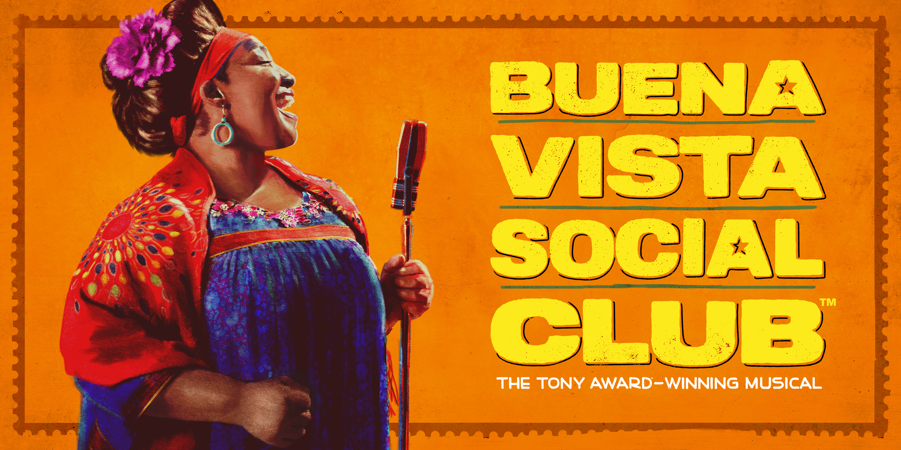

BUENA VISTA SOCIAL CLUB™ HOUSTON PREMIERE AT
THE HOBBY CENTER NOV 17 – 22, 2026
WINNER OF 5 TONY AWARDS® AND THE GRAMMY® FOR
BEST MUSICAL THEATER ALBUM
CRITIC’S PICK! “BUENA VISTA SOCIAL CLUB™ BRINGS THE THRILL OF MUSIC MAKING TO BROADWAY.”
The New York Times
“THE MOST INTOXICATING AND RAPTUROUS SHOW OF THE BROADWAY SEASON!”
Variety
“ELECTRIFYING AND TRANSPORTIVE, WITH INTOXICATING MUSIC AND SPIRITED DANCE—
I FELT WHISKED AWAY.”
The New York Post
WHO: Memorial Hermann Broadway at the Hobby Center
WHAT: BUENA VISTA SOCIAL CLUB™
WHEN: November 17 – 22, 2026
Tues – Fri at 7:30 pm | Sat at 2 & 7:30 pm | Sun at 1:30 & 7:00 pm
WHERE: The Hobby Center | 800 Bagby Street | Houston, TX 77002
TICKETS: Start at $55. Available online at TheHobbyCenter.org or BroadwayAtTheHobbyCenter.com, and in person at the Hobby Center Box Office (800 Bagby Street, Houston, TX 77002). Discounts available for groups of 10 or more. Call (888) 451-5986 or email Houston.groups@broadwayacrossamerica.com.
(HOUSTON, TX) – Memorial Hermann Broadway at the Hobby Center announces single tickets for the Tony® and GRAMMY® Award-winning BUENA VISTA SOCIAL CLUB™ will go on sale the general public on Friday, August 21 at 10am. BUENA VISTA SOCIAL CLUB™ will make its Houston premiere for a limited one-week engagement at the Hobby Center for the Performing Arts, November 17 – 22, 2026 as part of the Memorial Hermann Broadway at the Hobby Center 2026-2027 Season.
It’s been years since legendary singer Omara Portuondo last entered a recording studio. Once known as the “Queen of Feeling,” her voice was celebrated throughout Cuba – until she vanished from the spotlight. But when an ambitious young record producer brings her a rare opportunity, the elusive diva must finally reckon with her past.
Hailed as a "jaw-dropping, soul-stirring must-see" (The Washington Post), BUENA VISTA SOCIAL CLUB™ is a journey through music and memory into the beating heart of Havana. A world-class company brings the story of the iconic album to thrilling life in this tale of big dreams, second chances, and music that needs no translation.
BUENA VISTA SOCIAL CLUB™ won 5 Tony Awards® including Best Performance by an Actress in a Featured Role in a Musical (Natalie Venetia Belcon), Best Sound Design of a Musical (Jonathan Deans), Best Choreography (Patricia Delgado & Justin Peck), and Best Orchestrations (Marco Paguia). A Special Tony Award® was awarded to the musicians who make up the band of Buena Vista Social Club, and the Original Broadway Cast Recording received the Grammy Award for Best Musical Theater Album.
With a book by Tony® Nominee Marco Ramirez (Drama Desk Award, The Royale), Tony®-nominated director Saheem Ali (Fat Ham) leads an ensemble of visionary performing artists, including a band of renowned musicians from across the globe to tell the legendary story of the artists who recorded the original album. BUENA VISTA SOCIAL CLUB™ features the soul-stirring music of Cuba’s golden age, choreography by Tony Award® winners Patricia Delgado and Justin Peck (Illinoise, Steven Spielberg's West Side Story).
On Broadway, the band of BUENA VISTA SOCIAL CLUB™ features creative consultation by David Yazbek, music supervision by Dean Sharenow, orchestrations and arrangements and music direction by Tony Award® winner Marco Paguia, additional arrangements by Javier Diaz and David Oquendo, music consultation by Juan de Marcos.
BUENA VISTA SOCIAL CLUB™ features scenery by Tony® nominee Arnulfo Maldonado, costumes by Tony® nominee Dede Ayite, lighting by Tony® nominee Tyler Micoleau, sound by Tony Award® winner Jonathan Deans, wigs, hair & make-up by J. Jared Janas, and casting by The TRC Company.
The North American Tour of BUENA VISTA SOCIAL CLUB™ is produced by Orin Wolf, John Styles, Barbara Broccoli, Atlantic Theater Company, Luis Miranda, LaChanze, John Leguizamo and NETworks Presentations with Executive Producer Hannah Rosenthal.
BUENA VISTA SOCIAL CLUB™ and WORLD CIRCUIT RECORDS released the show’s Grammy® Award-winning Original Broadway Cast Recording, produced by Dean Sharenow and David Yazbek. The album is co-produced by Marco Paguia and Orin Wolf, and Executive Produced by Allan Williams.
BUENA VISTA SOCIAL CLUB™ made its world premiere at the Atlantic Theater Company, New York City in December 2023 and was nominated for Best Musical by the Drama League and Outer Critics Circle organizations.
The Hobby Center for the Performing Arts deepens understanding of shared humanity by presenting engaging performances and educational programs that strengthen a sense of belonging and help shape a more cohesive and connected Houston community. Opened in 2002, the Hobby Center campus features three distinctive performance spaces: 2,650-seat Sarofim Hall, 500-seat Zilkha Hall, and the intimate 150-seat Founders Club. Welcoming more than 450,000 audience members each year, the Hobby Center presents a broad range of arts experiences, including the Memorial Hermann Broadway at the Hobby Center series, a full season of musical theater produced by Principal Resident Company Theatre Under The Stars, and performances by Houston, national, and international artists. Education and accessibility initiatives are central to the Hobby Center’s impact. Through programs such as the ExxonMobil Discovery Series, the Hobby Center welcomes thousands of students to free, curriculum-connected performances while providing educators with classroom resources to extend learning beyond the stage. Please visit TheHobbyCenter.org. Follow the Hobby Center on Facebook and Instagram.
Broadway Across America (BAA), part of The John Gore Organization family of companies, is a leading presenter, distributor, operator, and marketer of Broadway theater worldwide. Led by owner John Gore, a record 27-time Tony Award winner and Emmy Award recipient, BAA pioneered the Broadway subscription touring model and is the leading presenter of first-class Broadway productions across more than 45 North American markets. Since its founding, BAA has produced, presented, and invested in hundreds of Broadway, touring, and international productions, helping introduce millions of theatergoers to the power of live performance. The organization is committed to expanding access to the arts through education, community engagement, and initiatives that inspire the next generation of artists, arts professionals, and audiences.
Follow on Facebook, Instagram, TikTok, Twitter, and @buenavistamusical.
For more information, visit buenavistamusical.com.

# # #

