Mickey Guyton Announces "Mickey Guyton & Friends Holiday Tour"

12-DATE HOLIDAY RUN TO INCLUDE THE HOBBY CENTER DECEMBER 6
BRINGING AN EVENING OF FESTIVE MUSIC AND SPECIAL GUESTS

GENERAL ON-SALE FRIDAY, JULY 31 AT 10 AM
Buy Tickets

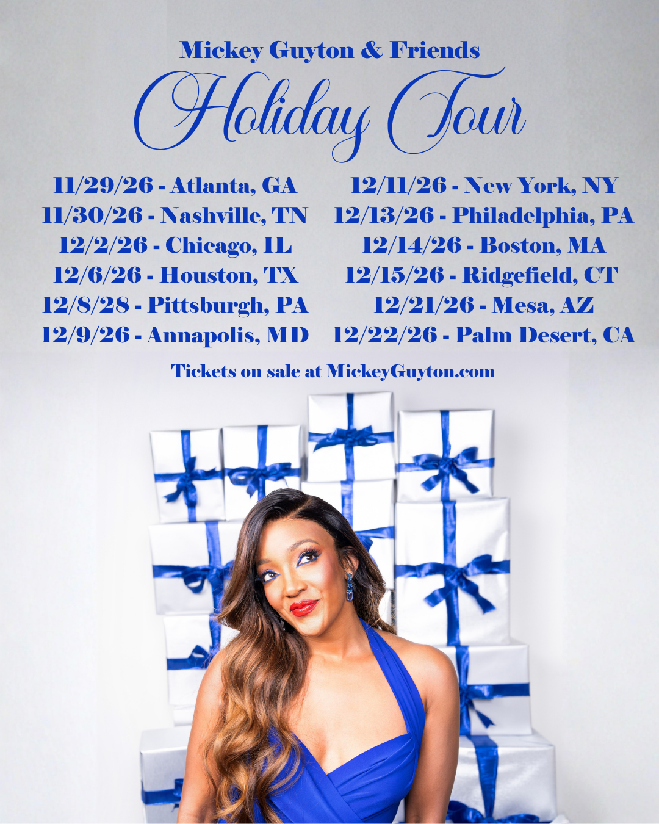
July 29, 2026 – Yesterday, four-time GRAMMY®-nominated artist Mickey Guyton announced her first-ever Mickey Guyton & Friends Holiday Tour, bringing the warmth, joy and spirit of the season to audiences across the country this winter.
Launching November 29 in Atlanta, GA, the 12-city run will feature an unforgettable evening of holiday favorites, songs from her acclaimed holiday album Feels Like Christmas, and special guest performances celebrating the most wonderful time of the year.
The tour follows the release of Mickey's first full-length holiday album, Feels Like Christmas, which earned praise from the Associated Press as one of the year's standout holiday releases. Featuring songs including fan favorites "Sugar Cookie," "Feels Like Christmas," and "Mistletoe Kisses," alongside timeless classics like "O Holy Night"and "Do You Want To Build A Snowman," the album showcased a new chapter of Mickey's artistry and quickly became a seasonal favorite.
Tickets for the Mickey Guyton & Friends Holiday Tour will first be available through the Artist Pre-Sale, beginning Tuesday, July 28 at 10:00 AM CT. Tickets go on sale to the general public beginning Friday, July 31 at 10:00 AM local time. For pre-sale sign-up, tickets and additional tour information, visit https://www.mickeyguyton.com/tour.
Since releasing her acclaimed holiday album Feels Like Christmas in late 2025, Mickey has continued to captivate audiences on some of entertainment's biggest stages. She promoted the album with appearances on CBS Mornings, TODAY, Tamron Hall, Access Hollywood, and Watch What Happens Live with Andy Cohen, performed in the Macy's Thanksgiving Day Parade, and made a cameo in Hallmark's A Grand Ole Opry Christmas. Most recently, Mickey performed at the NYC Pride Parade for the first time, and earlier this year, the NBA tapped Mickey to perform the national anthem ahead of Game 5 of the NBA Finals between the New York Knicks and the San Antonio Spurs, further cementing her status as one of music's most sought-after live performers.
MICKEY GUYTON & FRIENDS HOLIDAY TOUR DATES
Nov. 29 – Atlanta, GA
Nov. 30 – Nashville, TN
Dec. 2 – Chicago, IL
Dec. 6 – Houston, TX
Dec. 8 – Pittsburgh, PA
Dec. 9 – Annapolis, MD
Dec. 11 – New York, NY
Dec. 13 – Philadelphia, PA
Dec. 14 – Boston, MA
Dec. 15 – Ridgefield, CT
Dec. 21 – Mesa, AZ
Dec. 22 – Palm Desert, CA

